Website Address: <http://www.12306.cn/mormhweb/>

Briefly introduce 12306: this is the most famous website to buy train-tickets. It is officially supported by the government.

Here are some of the problems discovered.

1. The maintaining time (during which the website is out of service) is really long. From 23:00 P.M. to 7:00 A.M. everyday nobody could buy a train ticket here. As an official website of the government of China, this is not satisfying to the users. As is shown below, although there aren’t many users at that time period, the website isn’t available at night.

Severity Rating: 2

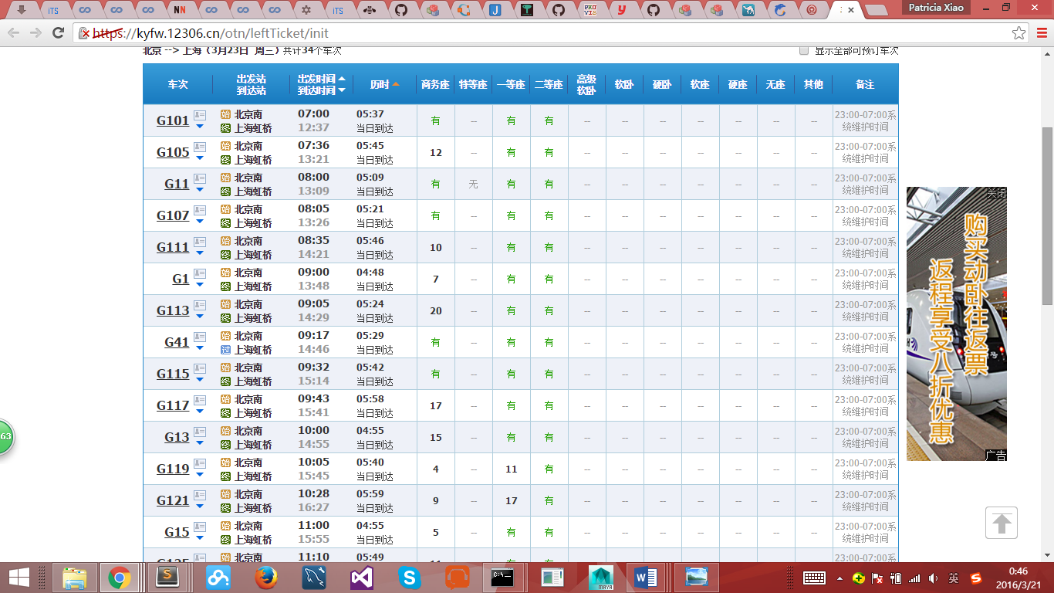

1. The interface of the main page simply ignored the principle of minimalism. It provides information far more than necessary, and it is really keen on putting advertisements on it. Not to mention that the information shown is not in an elegant way. It is by no means aesthetic, and the worst of all, it harms the principle of recognition. It makes it harder for users to get useful information at the first glance. Only the useless ads pop out.

Severity Rating: 2

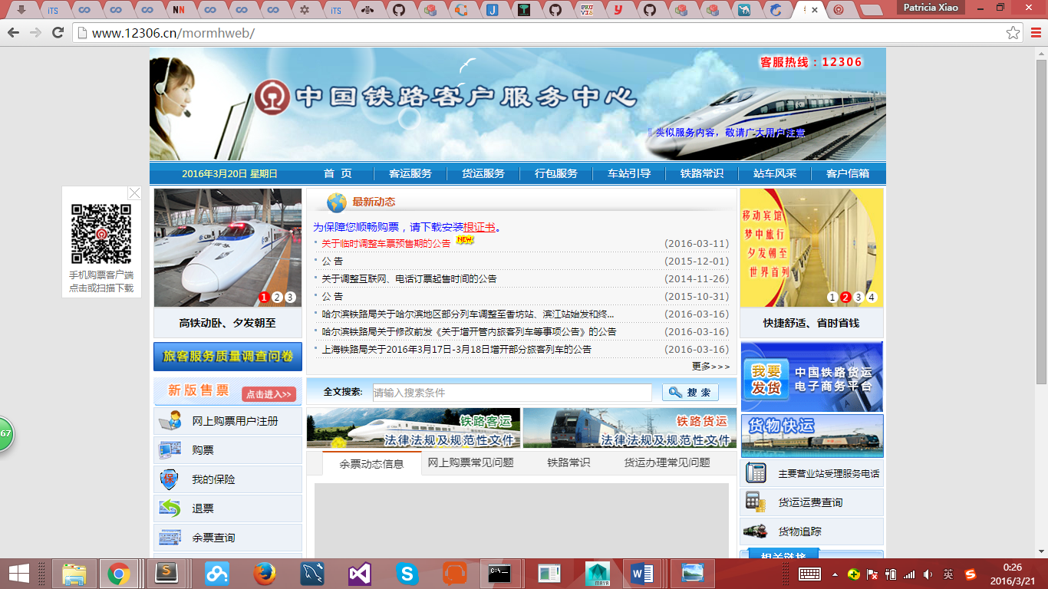

1. The verification code (in Chinese: 验证码) vandalize the flexibility and usability of the webpage dramatically.

Severity Rating: 3

Here are a few of the examples:

1. This is what happened when you input your name and address and try to log-in.

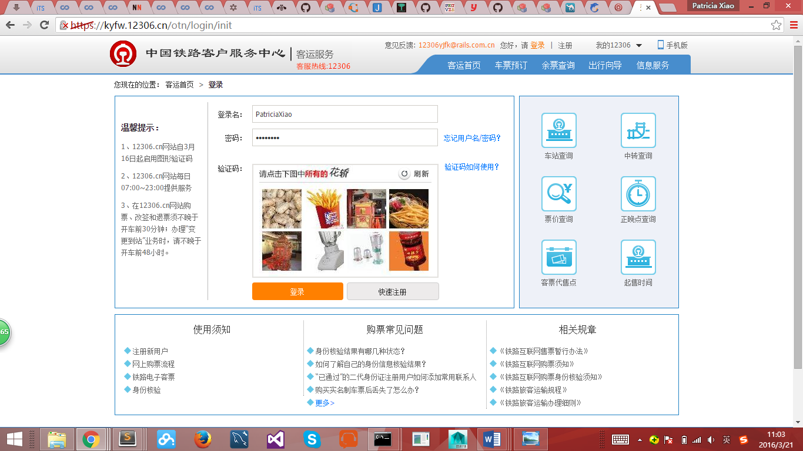



Shown in the above picture, the validation code asks you to click on all the bridal sedan chair (花轿) among all the pictures.

1. This is what happens when you book a ticket.

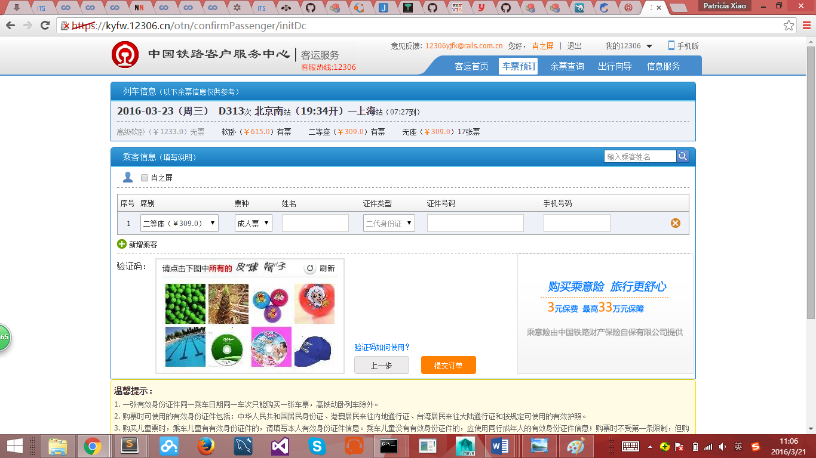

As is shown in the picture below (and above), it asks you to select all the rubber ball (皮球) and hat (帽子) in the pictures.



What’s more, if you happened to make mistakes while selecting the pictures, you’ll have to do it over and over again. There is no guarantee that the pictures are clear. Considering that there are always plenty of people buying them at the same time, the delaying caused by the validation code is likely to annoying the users.

However, it is understandable, for it is meant for reducing ticket resale. But as far as I know, it is somehow useless, and also, couldn’t be the best solution.

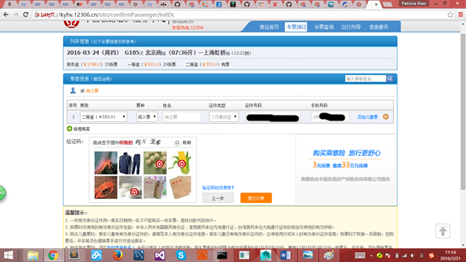

1. There are more flexibility problems (perhaps also related to freedom problems).

The system is designed in such a way so that you’ll have to buy ticket one by one (except that you’re bringing kids with you, see the entry on the right side of the bar with label “添加儿童票”, it means “adding tickets for children”). If you want to sit close to your friends or relatives that travel with you, you’ll have to come up with specific solutions, such as buying tickets as early as possible, for if there’re many people booking ticket, there’s no guarantee that you could grab tickets for seats located together.

Severity Rating: 4

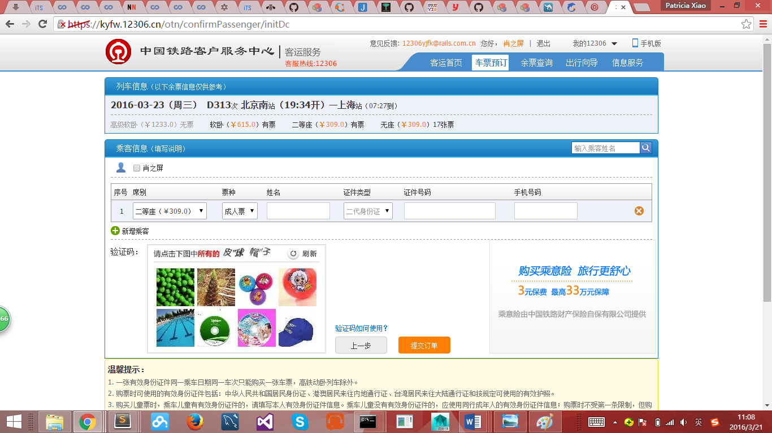

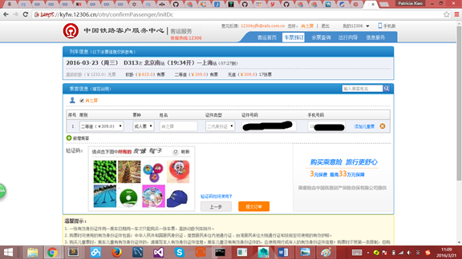

1. Still using the above two screen shots.

There are more problems than flexibility. This problem could be categorized into Mapping, Help or Freedom. After you log in, you could see only one checkbox of your own name. You could only check the checkbox and let the system automatically fills in your personal information. You can never fill in the blanks one by one by typing something in.

The reason why I say that it is a mapping problem is that, the design makes you feel as if you could buy a ticket for anyone else. There is a small search-box on the right saying that “输入乘客姓名” (input the name of the passenger), but I tried my friends’ names and the result is empty.

I have no idea if it actually works but I failed to find out how to use it. I have to say that there must be some problems with Help.

Severity Rating: 4

1. There are also problems with Error Preventing and Error Recovery. When pressing Backspace on the keyboard by mistake, the website, like many others, would go back to the previous page. That is understandable, but when you press forward again, you’ll lose part of the information you previously input about the ticket you’d like to buy.

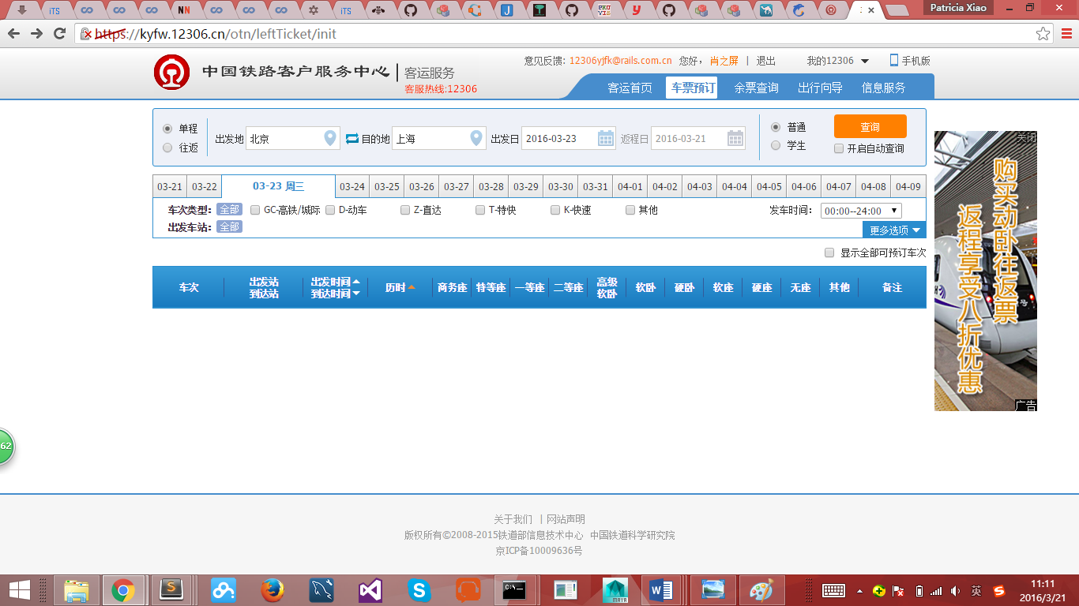

What’s more, you’ll never get to the confirm-passenger page again by pressing on “→” .

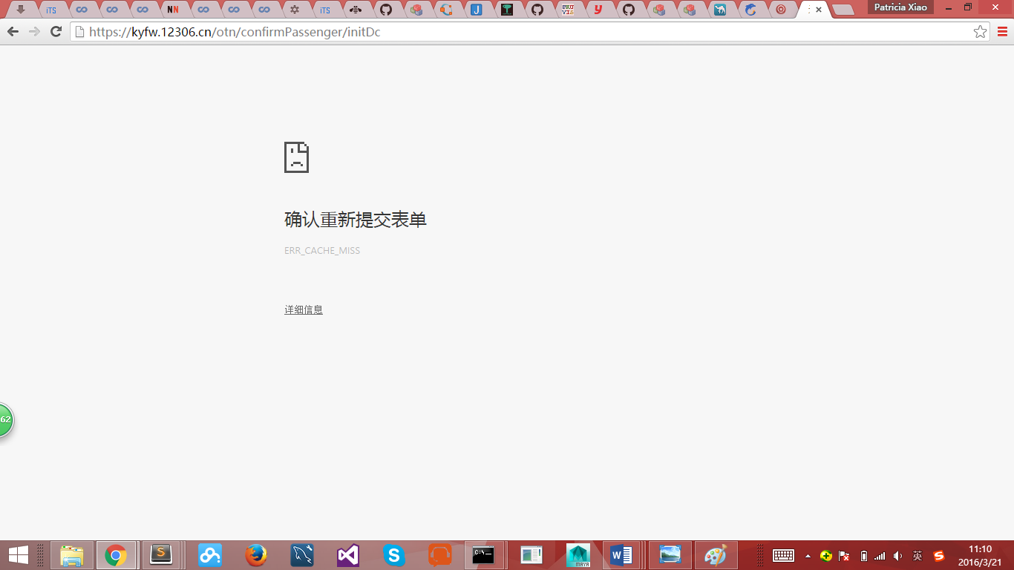

It is quite obvious that this could easily cause you troubles.

Severity Rating: 4

1. There are more problems. As you can see, there is NO entrance to submit your personal questions. There are only “常见问题” (common questions) for help, but unfortunately there aren’t many of them. Once you have something to ask, you don’t know what to do. The common solution would be google it, instead of asking for help on the official website.

Severity Rating: 2

